**VIWAPA IRP Report** *Links*

* [PDF](http://www.viwapa.vi/docs/default-source/default-document-library/draft----2019-wapa-integrated-resource-plan.pdf?sfvrsn=7a383714_2)

**Section 3: Major IRP Assumptions**

Assumptions made in the IRP:

*3.1 Inflation and Escalation Rates*

The general inflation rate is assumed to be 2.0% per year, and applies to the escalation of:

* Capital Costs
* Fixed O&M costs
* Non-fuel variable O&M cost escalation

This annual rate is applied to initial costs to derive estimates of future year costs

*3.2 Financing Assumptions*

Historically, VIWAPA has financed new generation using 100 percent debt. After Hurricanes Irma and Maria, the US federal government (through FEMA and HUD) committed to provide significant grant funding for new generation, contingent upon several conditions including the completion of VIWAPA IRP.

In July 2019, it was initially assumed that the grant funding amounting to $200 million would be provided to VIWAPA. To estimate these costs, the IRP estimates two measures of system costs:

* *Total Cumulative Present Worth Cost (CPWC)* including capital costs of all new resources
* Another measure of *Cumulative Present Worth Cost* which assumes that US government funding will not be repaid by VIWAPA or the Virgin Island

*3.3 Present Worth Discount Rate*

The various plans to expand generation capacity are compared on a present worth basis (i.e., the CPWC measures detailed in Section 3.2 above).

*These measures involve discounting the estimated incremental cost of serving load each year back to the start of the study period (2020 in this IRP), and then summing up the discounted annual costs numbers to derive a single CPWC amount.*

The normal convention in most IRPs is to use a discount rate equal to the utility’s *weighted cost of capital*. In the case of VIWAPA, the capital mix has traditional involved 100 percent debt financing and the cost of this debt funding would normally be used for the discount rate. The grant funding and VIWAPA’s current lack of access to the capital market makes the selection of a discount rate less straightforward.

**Weighted Cost of Capital**

The rate that a company is expected to pay on average to all its security holders to finance its assets.

The WACC represents the minimum return that a company must earn on an existing asset base to satisfy its creditors, owners, and other providers of capital.

For this IRP, two discount rates are used depending on the source of funding:

* For US government grant funding – assumed to apply to all new unit capital costs – are discounted at *three percent*
* For remaining costs, an assumed *five* percent cost is used

*3.4 Levelized Fixed Charge Rate*

The *fixed charge rate* (FCR) is the revenue requirement needed to offset the fixed charges during a given year – the initial investment plus the interest charged to finance that investment.

A separate FCR can be calculated and applied to each year of an economic analysis, but it is common to use a single, levelized FCR that has the same present value as the year-by-year fixed charge rate as this is easier to apply than a series of annual fixed charge rates.

In this IRP, a 20-year FCR recover period is assumed, with a three percent cost of funds (aka discount rate) as the basis of the FCR calculation

*3.5 Owner’s Costs*

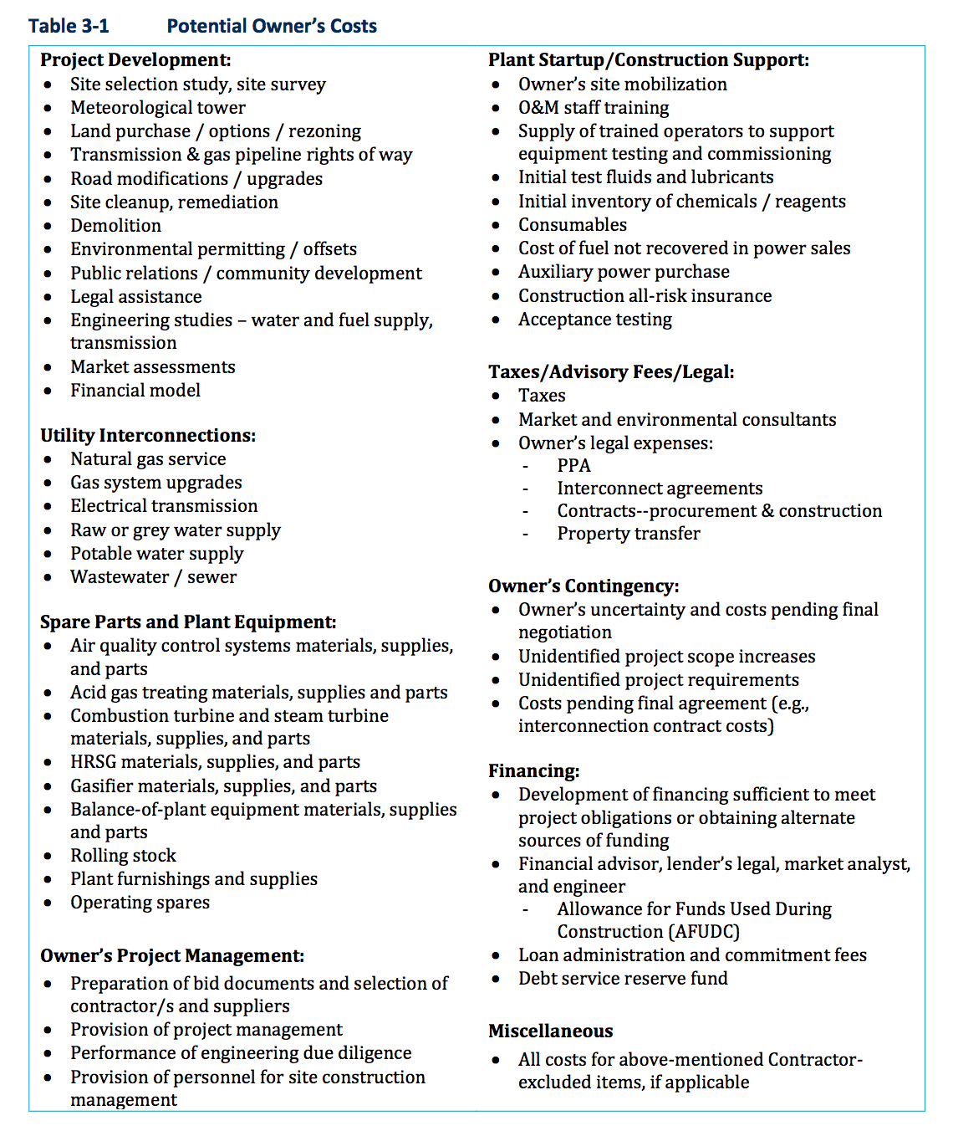The total capital costs of a power plant are commonly divided into two categories:

* Engineer-Procure-Construct (EPC) costs
* Owner’s costs

EPC costs include the cost of plant equipment and construction costs. Owner’s costs include everything else not included in an all-encompassing EPC bid, as shown in Table 3-1.

For this IRP, a 20-percent addition to the EPC costs has been added for all technologies.

*3.6 Interest rate applied during construction*

The last portion of the total capital cost of a new generating unit is the *interest during construction* (IDC), which accounts for the interest cost of using borrowed fund during the plant construction period.

*3.7 Load Forecast*

When performing an IRP, detailed assumptions are required about utility peak demand over the forecast period and energy required each year. Most of the time, forecast of peak demand and energy requirements of the system is developed using the historical relationship between energy consumption/peak demand and independent variables such as population, energy price, and temperature data. But, with the destruction of the VIWAPA system in 2017, the power systems of the islands were destroyed and the ability to project future power needs based on historical data has been compromised.

Because of this, the load forecast in this study relies heavily on the judgment of the VIWAPA staff and other stakeholders who closely track the rebuilding of the power system, and have insight to the customers that might not return to the grid.

There are three load forecast estimates:

* **Base load forecast** assuming no growth during the 2020-2044 planning period, with peak demand in STX (St. Croix) at 38.3 MW in 2020
* **High load forecast** of flat load growth for five years, and then experiencing a stair-step increase of 25 MW in peak demand occurring three days a week, ten hours a day due to a new cruise ship port proposed in St. Thomas
* **Low load forecast** of decreasing energy consumption due to economic conditions, increased self-generation by consumers due to behind-the-meter installation of solar. The load forecast assumes load decreased of ten percent on each system over the next ten years.

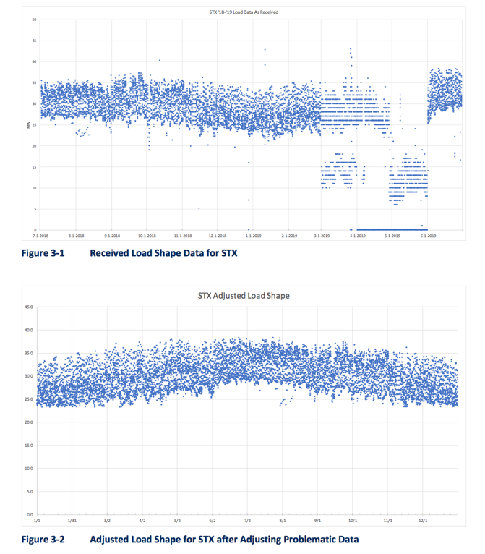*­­­3.8 Load Shape*

The load shape for this IRP is based on the July 2018 through June 2019 energy requirements of each VIWAPA system, to reflect post-hurricane system load characteristics. Obvious problematic data and outliers were adjusted based on load levels for comparable periods.

*3.9 Planning Reserve Criteria*

To meet peak demand, utilities are required to install additional capacity above peak demand such that shortages don’t occur if the peak demand is higher than anticipated or if a generating unit or transmission line is out of service due to an outage.

Some utilities adopt planning reserve criteria expressed as a *percent reserve margin*, often in the 12 to 20 percent range above the anticipated peak demand. The exact percent reserve margin depends on utility size, location, and interconnections of the utility itself, the larger the utility, the greater the interconnections with other utilities and less vulnerable to disruptions, resulting in a lower adopted planning reserve margin (more often than not).

Other utilities adopt a planning reserve criterion called the N – 1 approach that allows them to meet peak demand if the largest single unit or transmission line is out of service. VIWAPA has adopted the N – 1 – 1 planning criterion that allows them to meet peak demand in the even the largest two units or lines are out of service. This was preferred since VIWAPA has two small island systems and cannot rely on interconnections with other utilities (or its two systems) to serve loads.

In addition to the planning reserve criterion, VIWAPA has a *loss of load reliability* target with the goal of one day of lost load per ten-years in 2044, and one day of lost load per year in 2020. These criteria are applied to this IRP gradually, such that resources are added to meet the one day per year criterion no later than five years into the expansion plan (2024).

Because the loss of load criterion is not applied until 2024, a capacity reserve margin criterion is applied in the model from 2020 through 2024.

*3.10 Spinning Reserves and Frequency Regulation*

Spinning reserves refer to the ability of a utility to quickly increase generation if a unit trips and goes off-line unexpectedly. Normally, utilities plan their dispatch such that online units have sufficient unused generating capacity to quickly ramp-up and serve load if an outage occurs.

Some utilities require all spinning reserves to be from synchronized units, while other utilities may allow some of the spinning reserve requirements to come from quick-start units that are not synchronized but can come online in 10 minutes or less.

Another operational consideration impacting unit dispatch and economics involves the need to provide **system regulation** and **frequency response**, referring to the ability to increase or decrease electric output on a near-instantaneous basis in response to dispatch adjustments made to correct supply and demand imbalances.

Resources that provide regulation must have the technical capability to ramp up or down quickly (as measured by the MW/minute ramp rate) and are equipped with automatic generation control (AGC) such that the system operator can send signals electronically and achieve near immediate results. Examples of technologies that are well-suited to provide regulation include battery storage system (BESS), hydroelectric generation with reservoirs, and reciprocating internal combustion turbines.

The importance of planning for adequate regulation has grown dramatically in recent years as intermittent, renewable resources such as wind and solar have penetrated most markets.

A system integrating intermittent RE resources must plan and operate such that sufficient resources provide frequency regulation is operational in case RE output encounters a sudden increase or decrease. For small, isolated systems such as STX, a failure to provide adequate regulation can result in load shedding and unstable power networks.

The intermittent and unpredictable nature of sources like wind and solar makes it difficult to plan for sufficient system regulation. 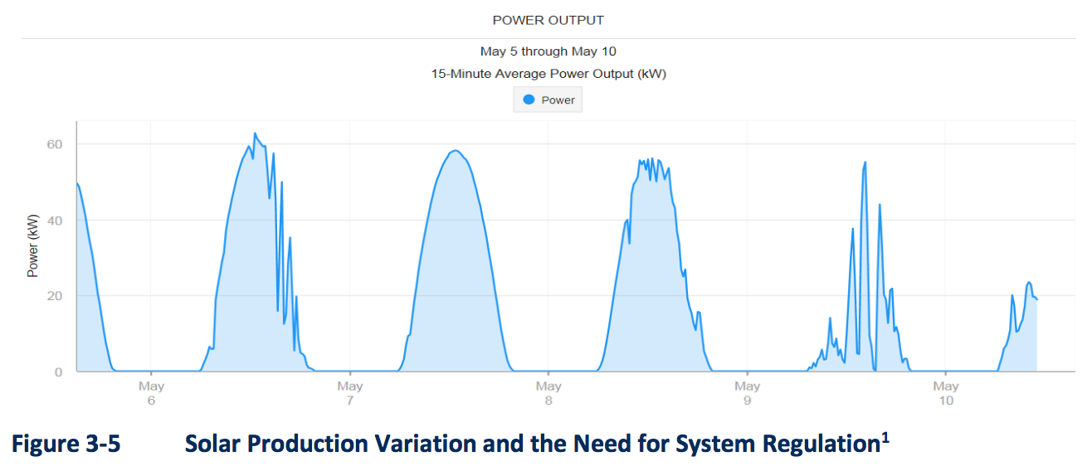

Wind can be less predictable than solar. The sudden decrease of wind generation shown in the graph resulted in frequent outages that required energy storage and changes in system regulation requirements.

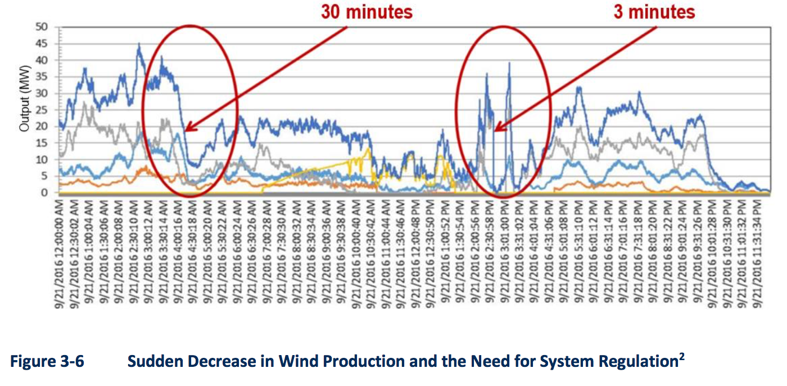

Interestingy, VIWAPA did not have sufficient spinning reserves because of the high costs as on-line units would need to be operated inefficiently, at less than full load levels.

For the IRP, 8 MW of synchronized spinning reserves are provided for both STT and STX. Additionally, frequency regulation requirements were set to equal to fifty percent of the renewable energy capacity online during ay hour.